1. Open one of the documents in the Post-War Iraq folder.
2. Go to Save As.
3. Save the document in the Processed Document folder.
4. Go back to the Post-War Iraq folder and move the document into the Original documents folder.
5. Move the date and venue into the header of the document.

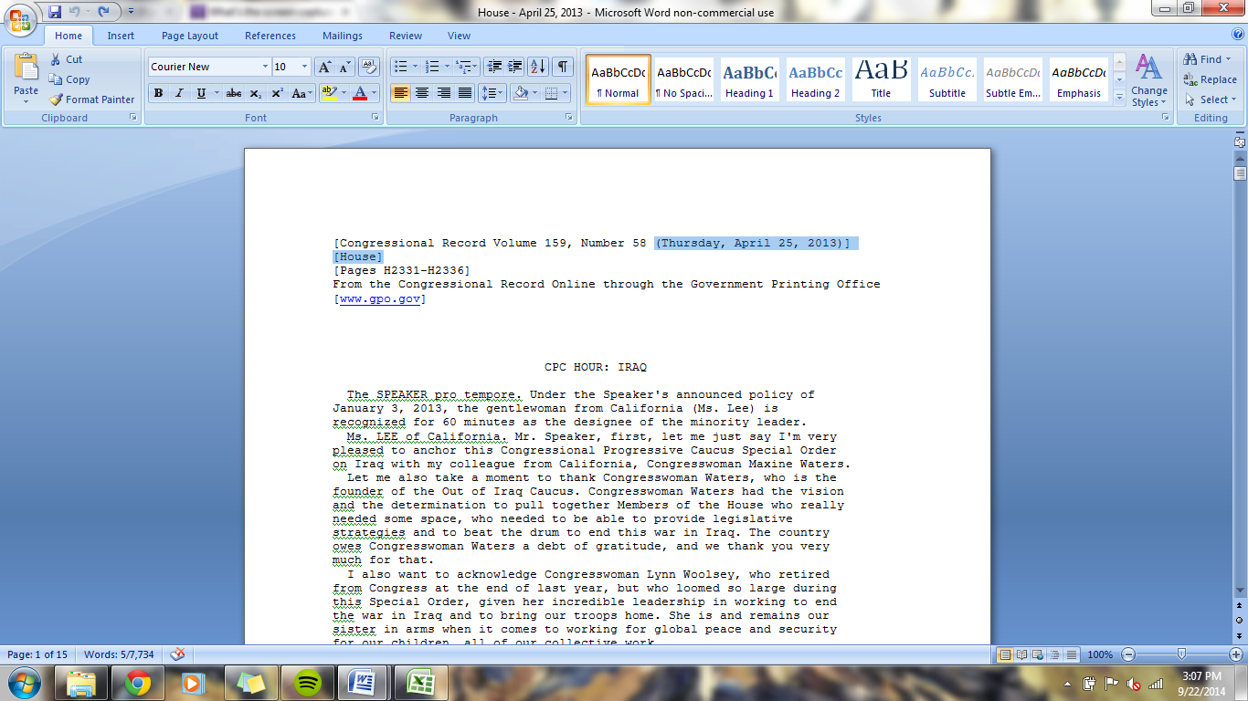

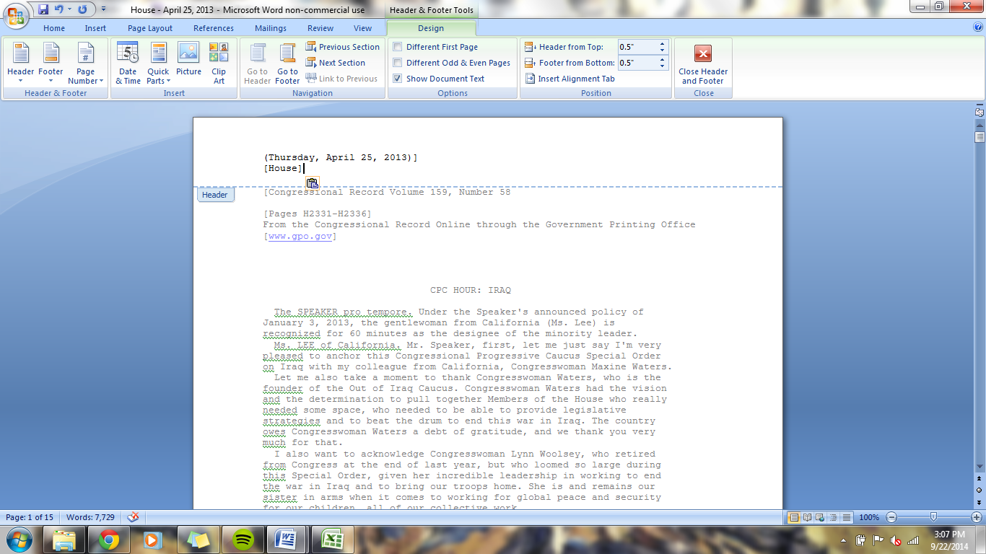

1. Delete the info that is highlighted below.

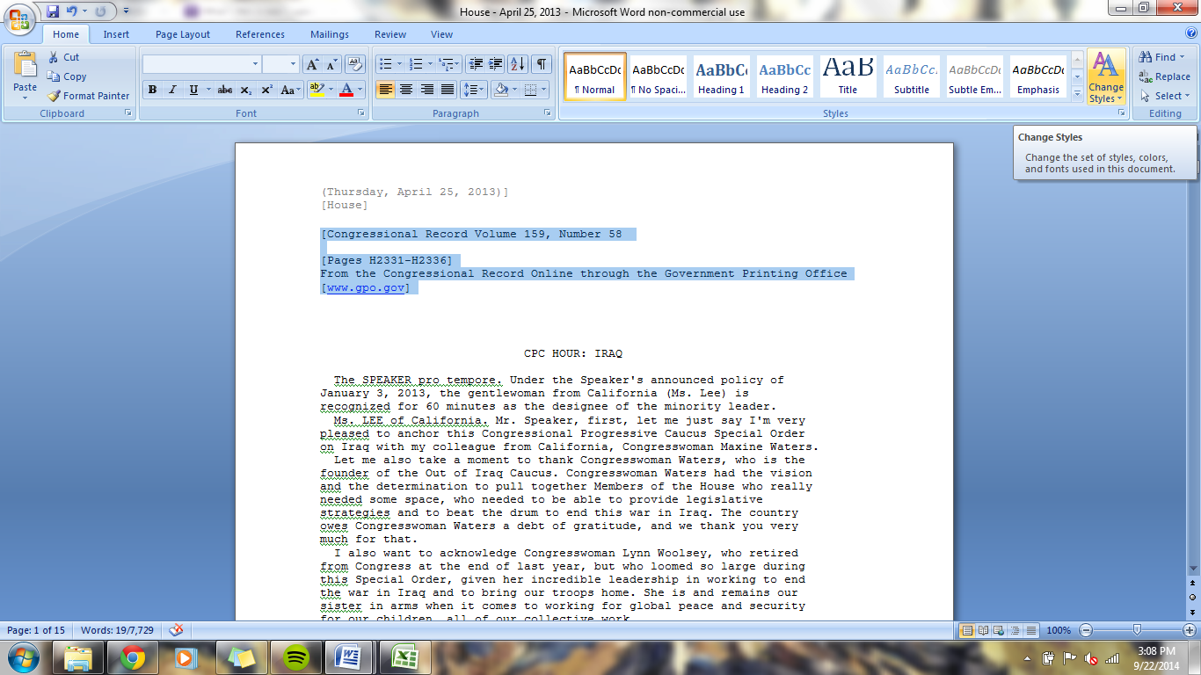

1. If the speaker’s state is listed, record that information in the excel sheet.

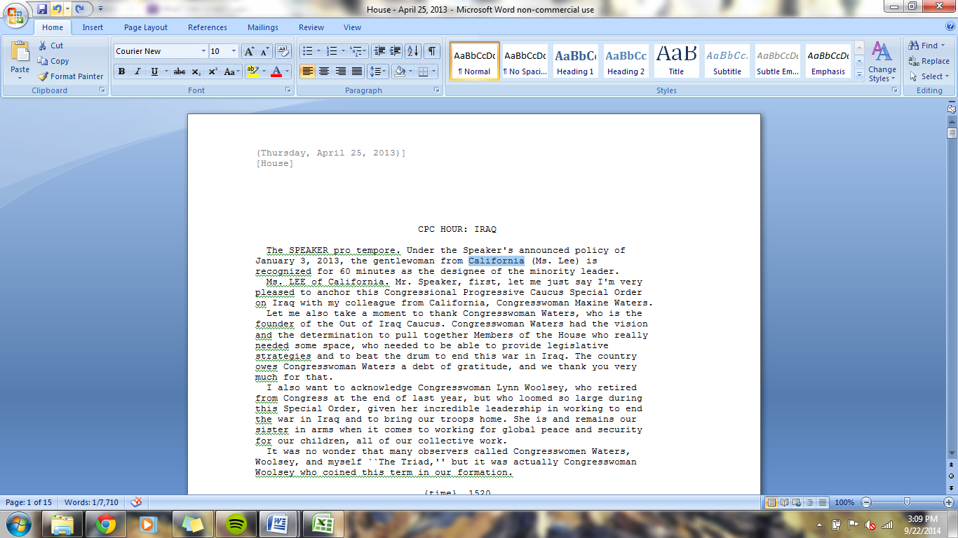

1. Delete the title of the speech and anything said by the Speaker pro Tempore.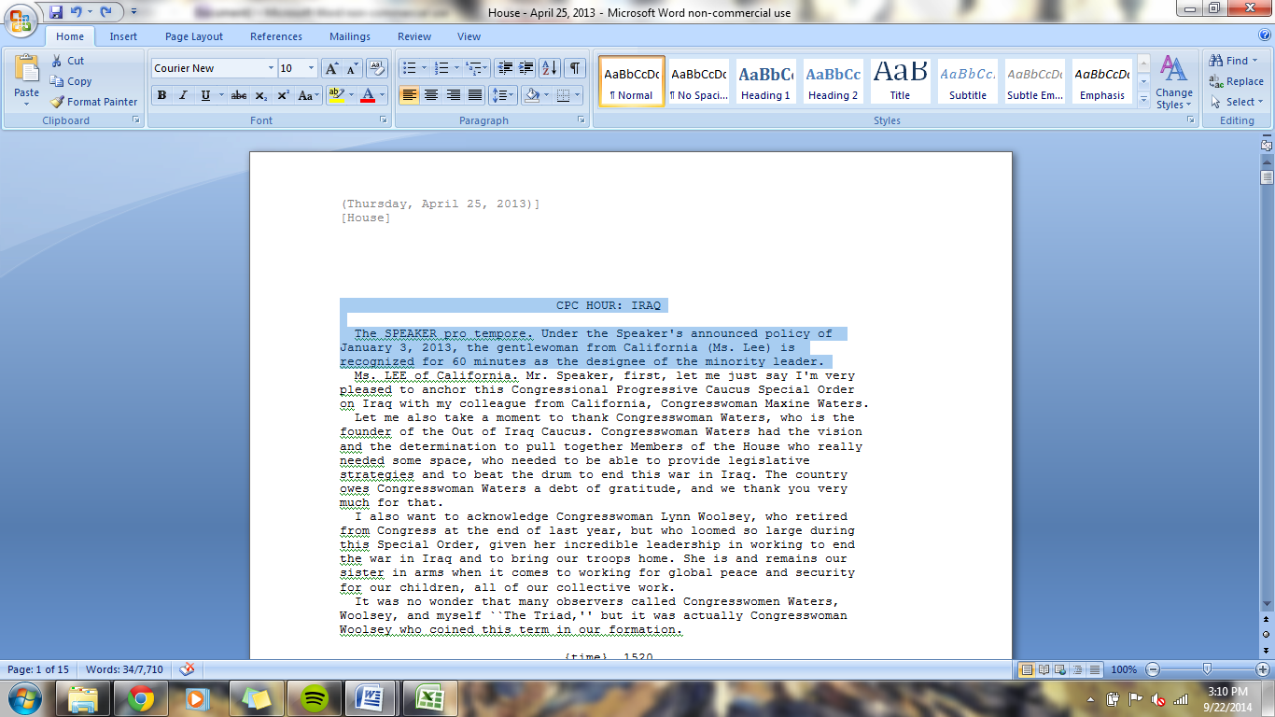
2. Move the name of the speaker to the header.

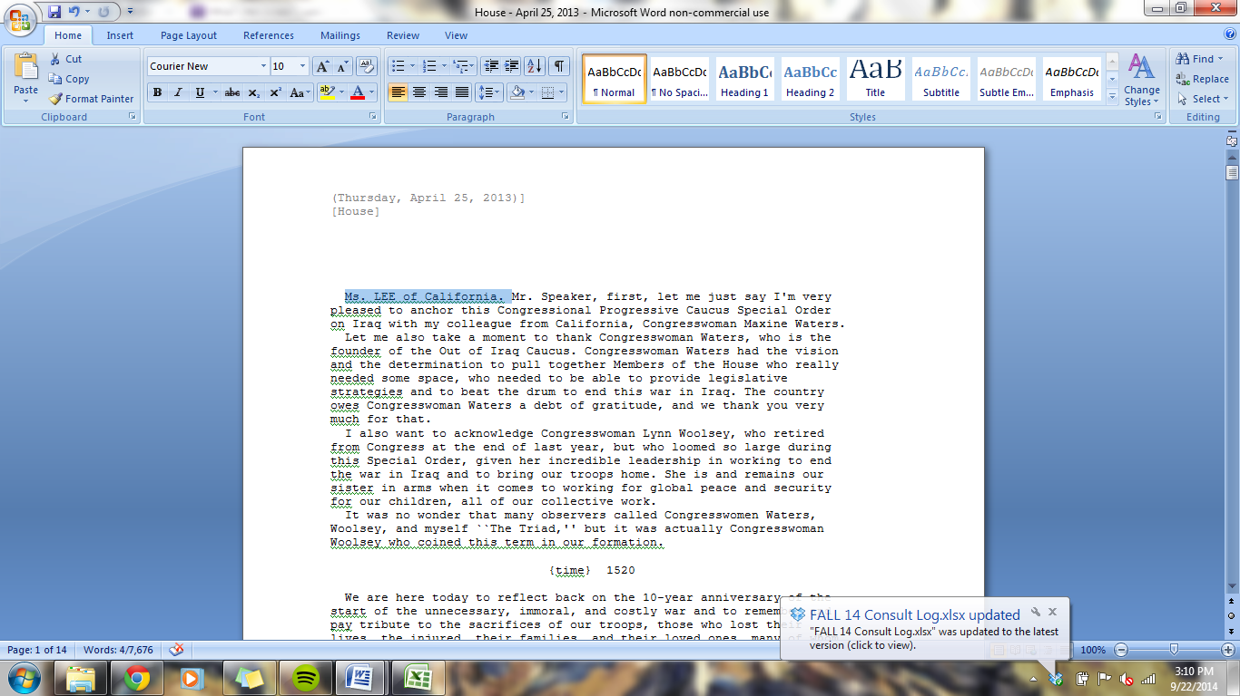

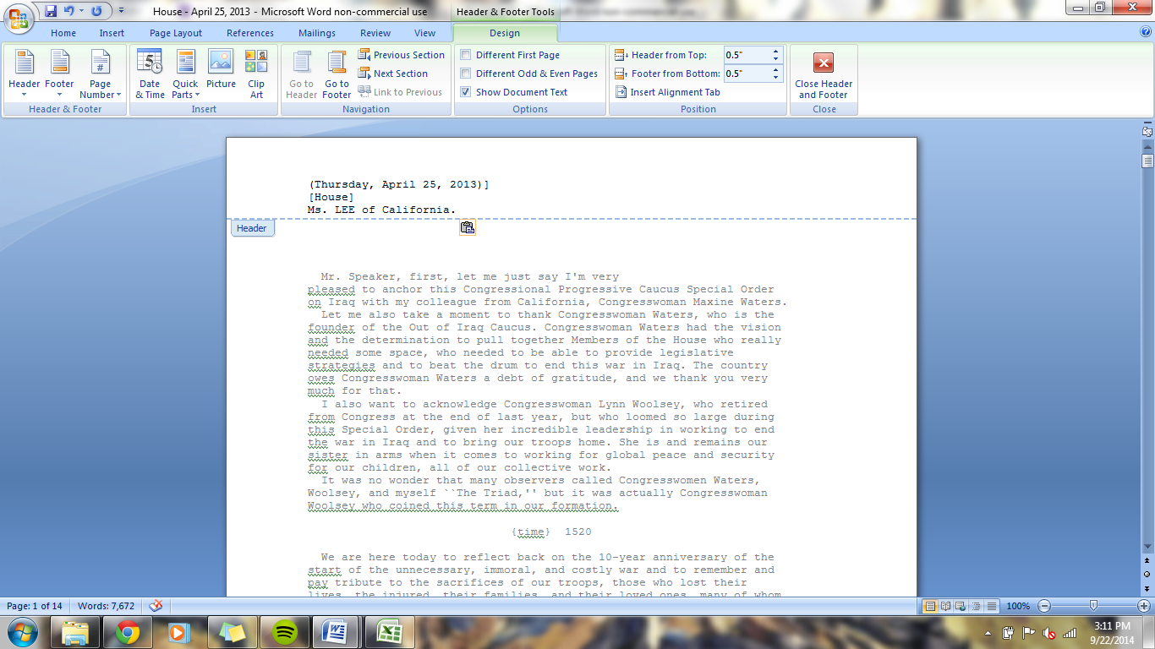

1. Delete page numbers and other extraneous information such as what is depicted below.

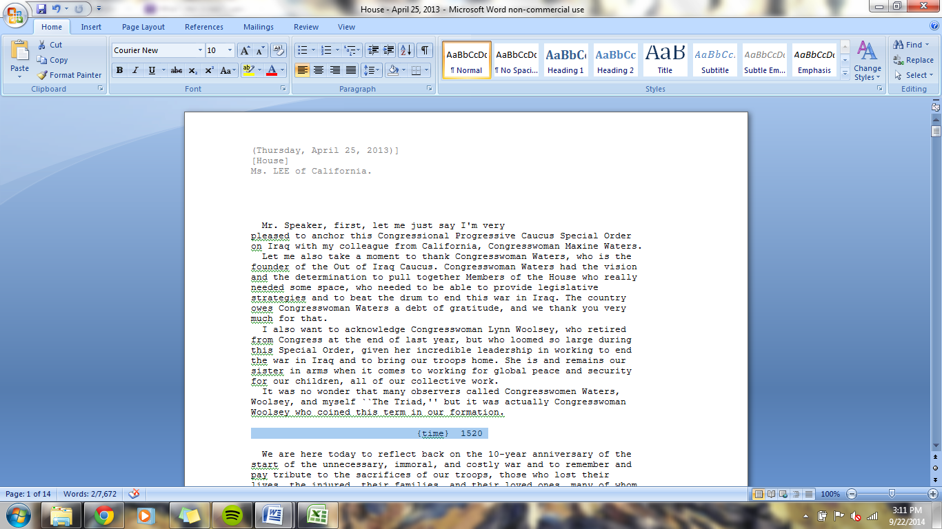

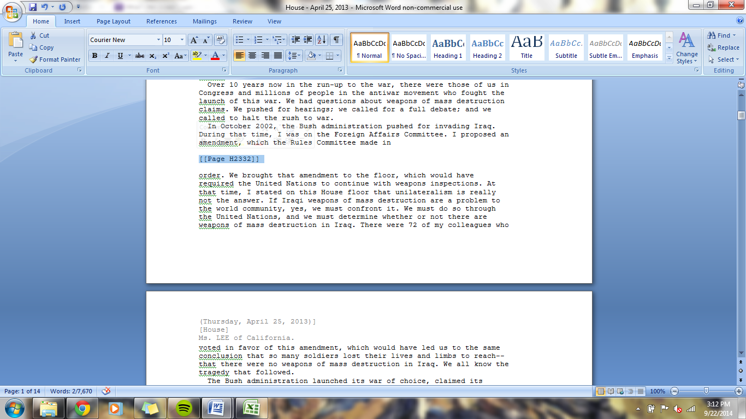

1. Separate text from different speakers using several spaces. Demonstrated below.

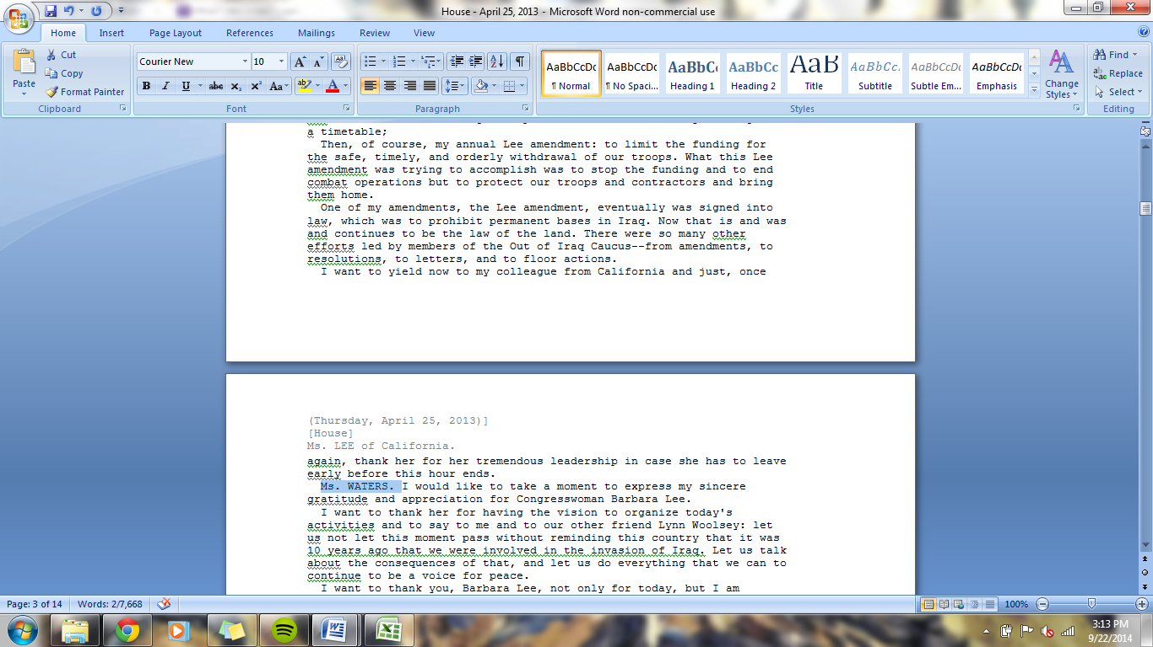

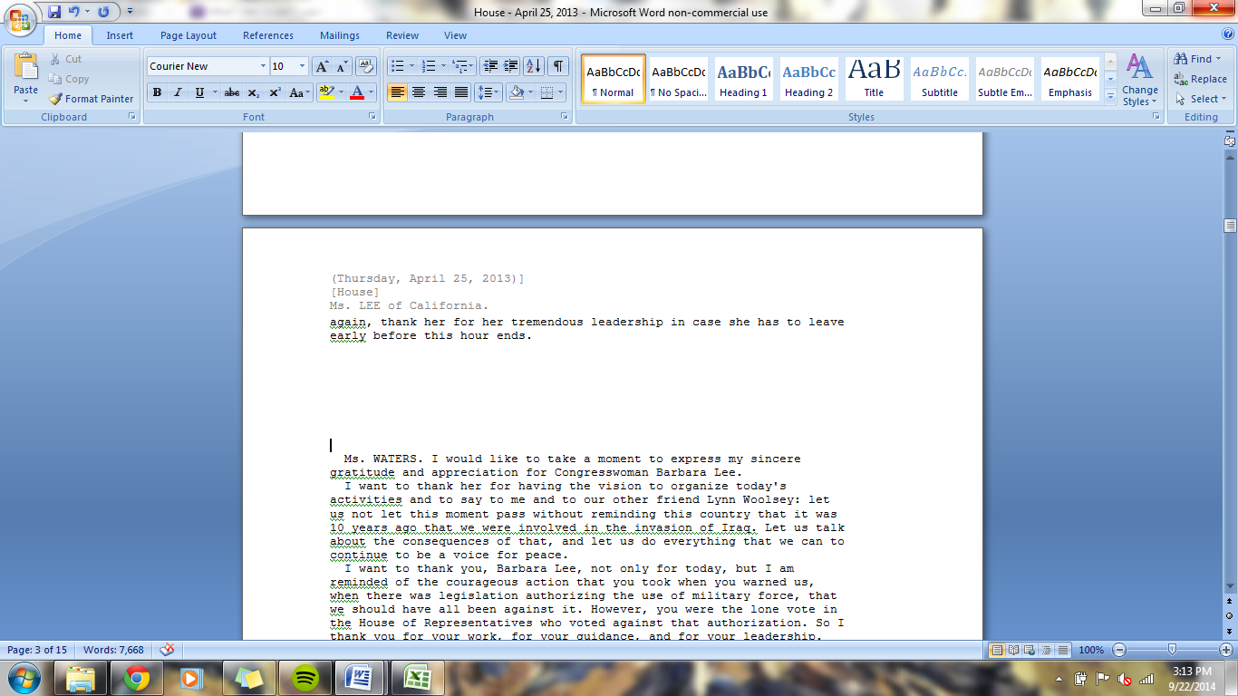

1. Correct obvious spelling errors.

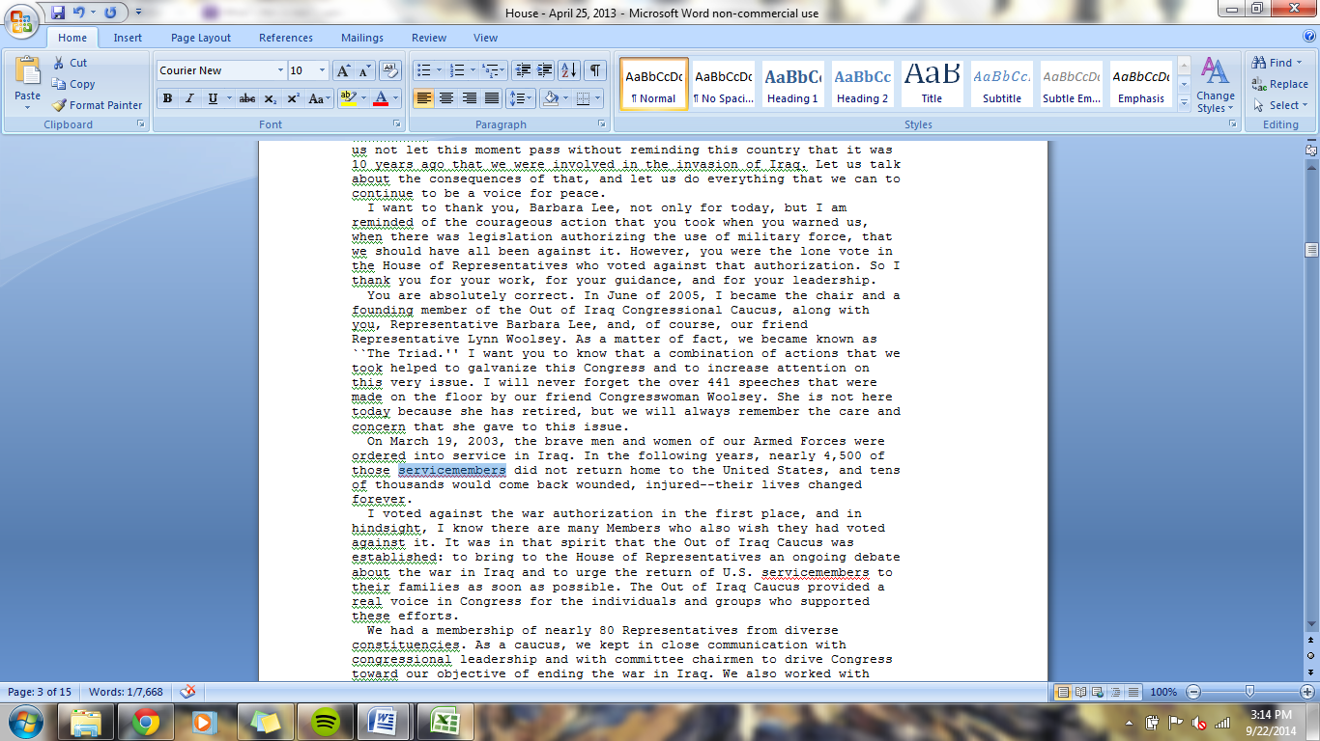

1. Delete all block quotes.

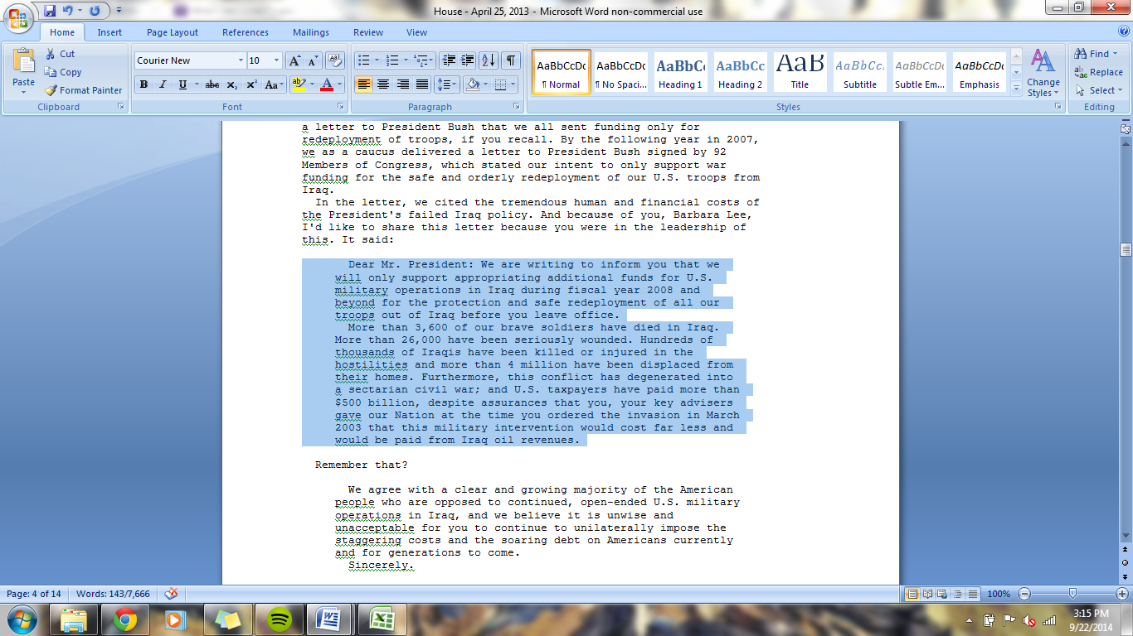

1. Make sure to identify all speakers and clearly separate them.

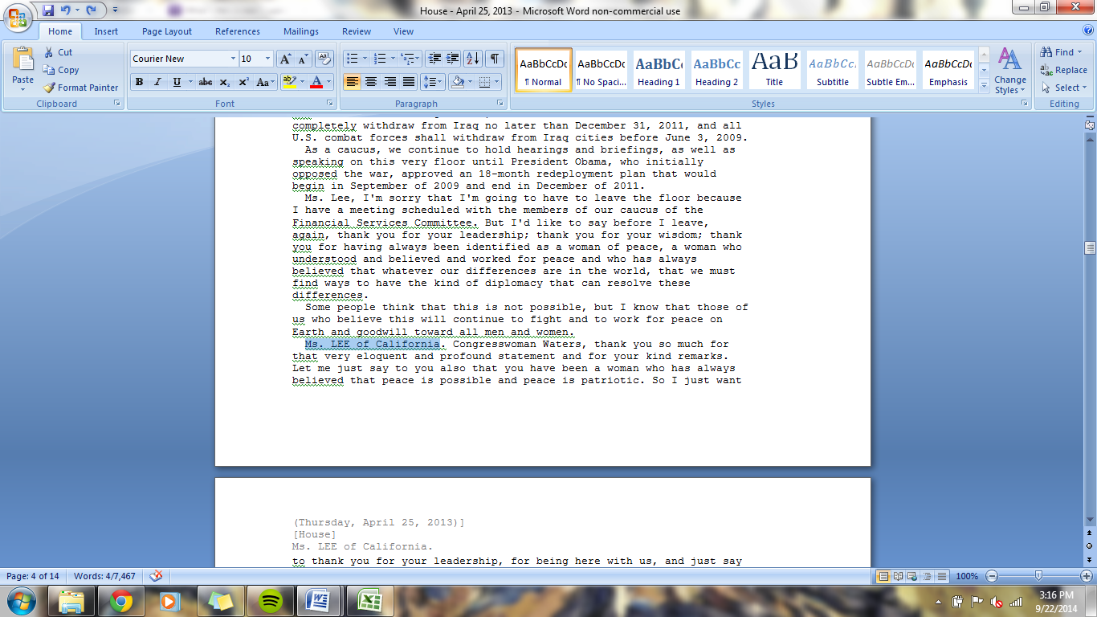

1. Delete irrelevant speeches that do not pertain to Iraq. If unsure, make a note of it and ask about it.

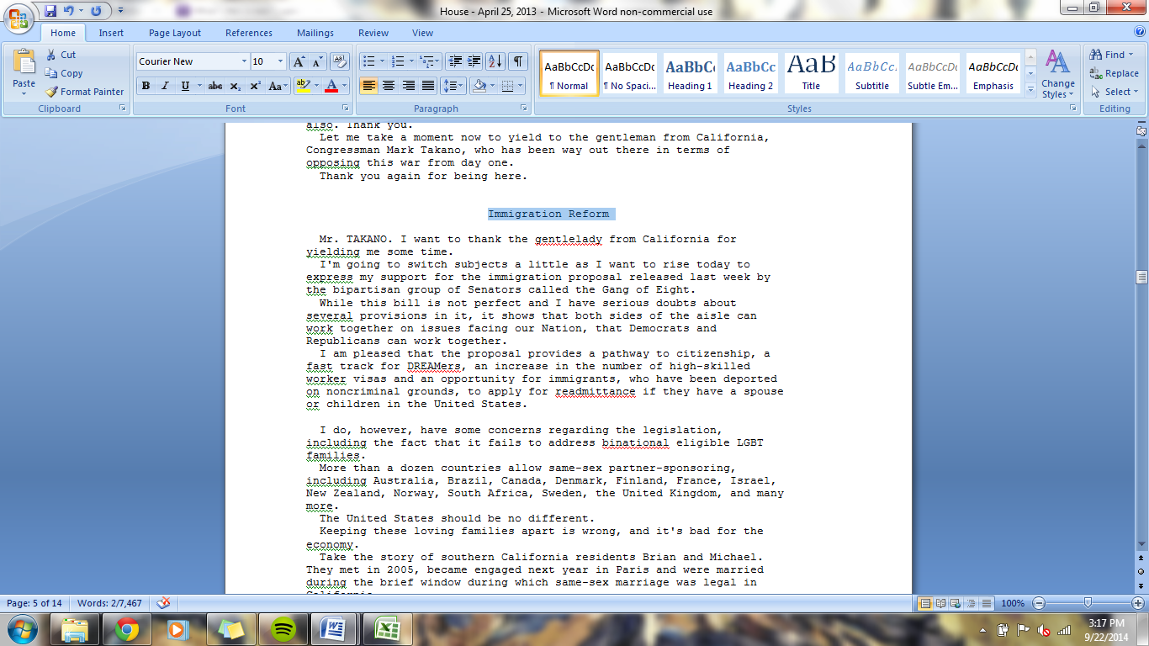

1. Delete everything from the Speaker pro tempore.

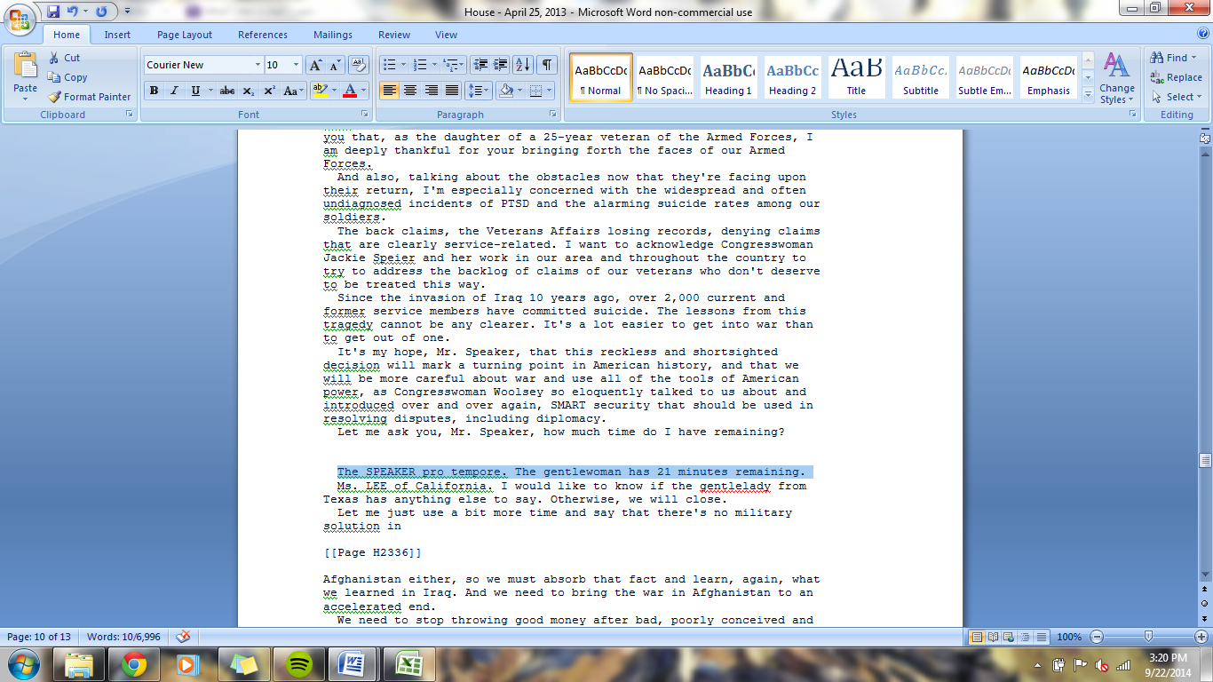

1. Delete extra information at the end of the document. This will be indented and usually pertain to voting.

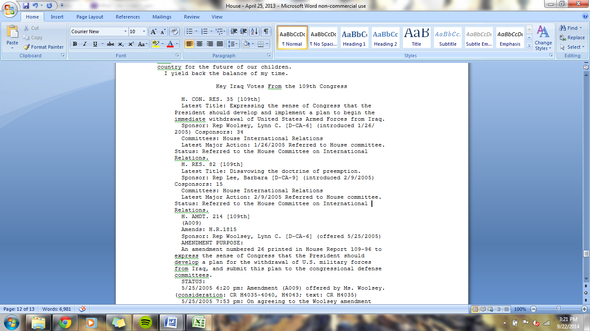

1. Now you want to separate out different speakers into different word documents.
2. Open a new word document.
3. Copy the date and the venue into the new document’s header.

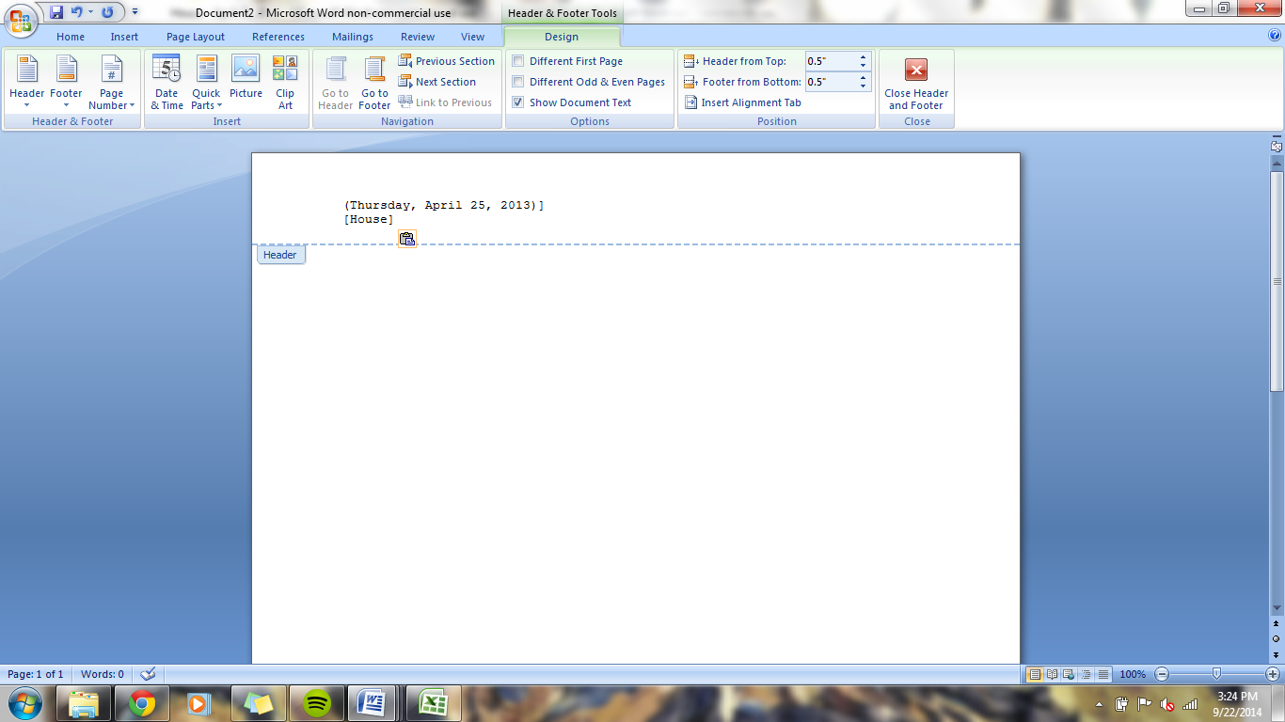

1. In the other document, find the second speaker.

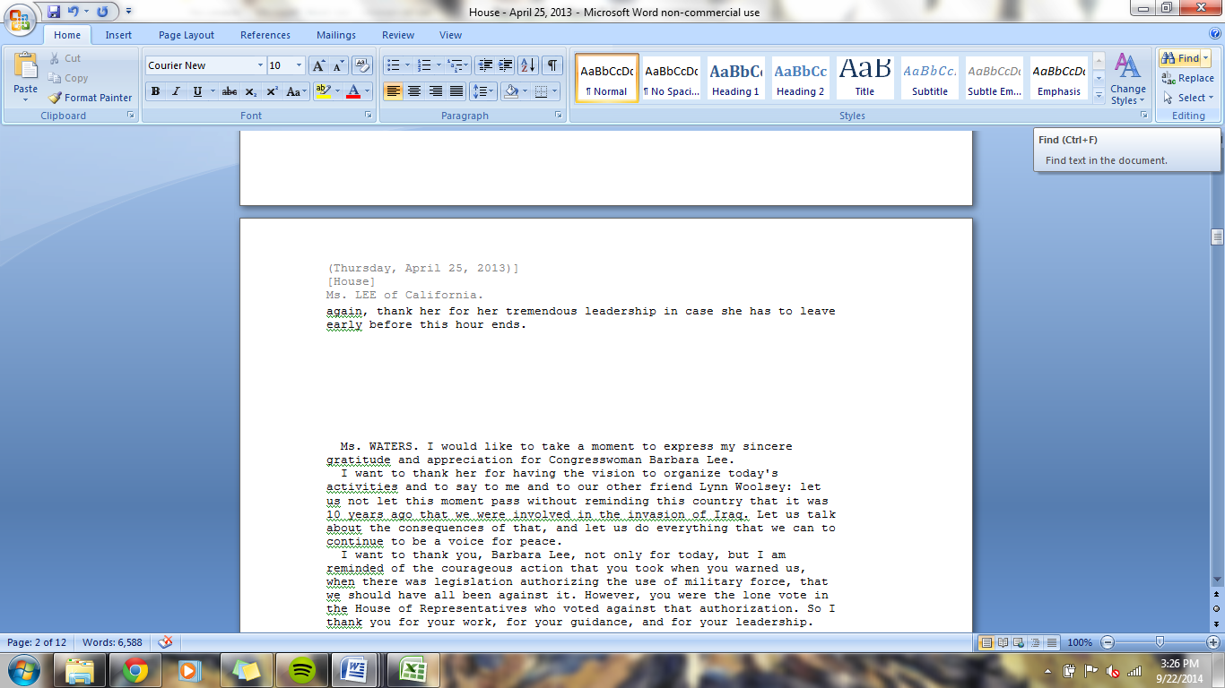

1. Copy that name into the header of the new document.

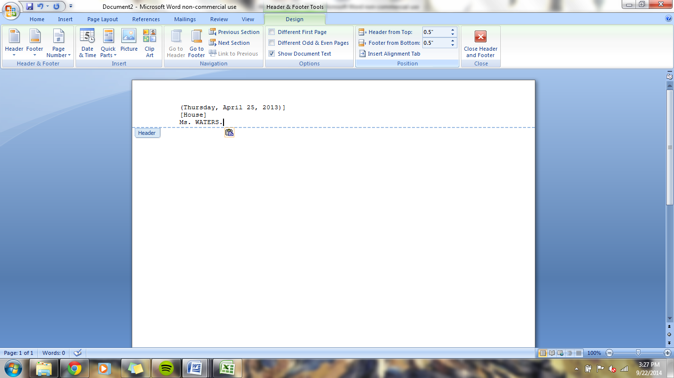

1. Cut everything said by that speaker and paste it into the new document.
2. After everything by that speaker is in the new document, save that document to the Processed Documents folder which is in the Data-Post War Iraq folder.

\*\*Note: The only reference to the speaker should be in the header. At this stage, delete any extra names that appear in all caps at the beginning of a paragraph.

1. Name it this way: “ID#.Name.Month.Day.Year” . For example, “2500.Waters.4.25.13”

\*\*\*The ID# will be in the excel sheet which you should fill out for each word document.

1. Repeat these steps until only the first speaker is left in the original document.
2. Rename that document using the format: ID#.Name.Month.Day.Year”

Alternative

1. Open one of the word documents.
2. File -> Save as.
3. Save as the speakers name and date such as “Kennedy.9.26.06”.
4. Clean up the file. Steps 5-10 and 12-13 and 15-17.
5. Add to Excel sheet.
6. Rename the document to include the ID # from Excel sheet such as “3141.Kennedy.9.26.06”